What is an Embedded System?
At its core, an embedded system is a specialized computer system designed to perform a dedicated function or a small set of functions within a larger mechanical or electrical system.

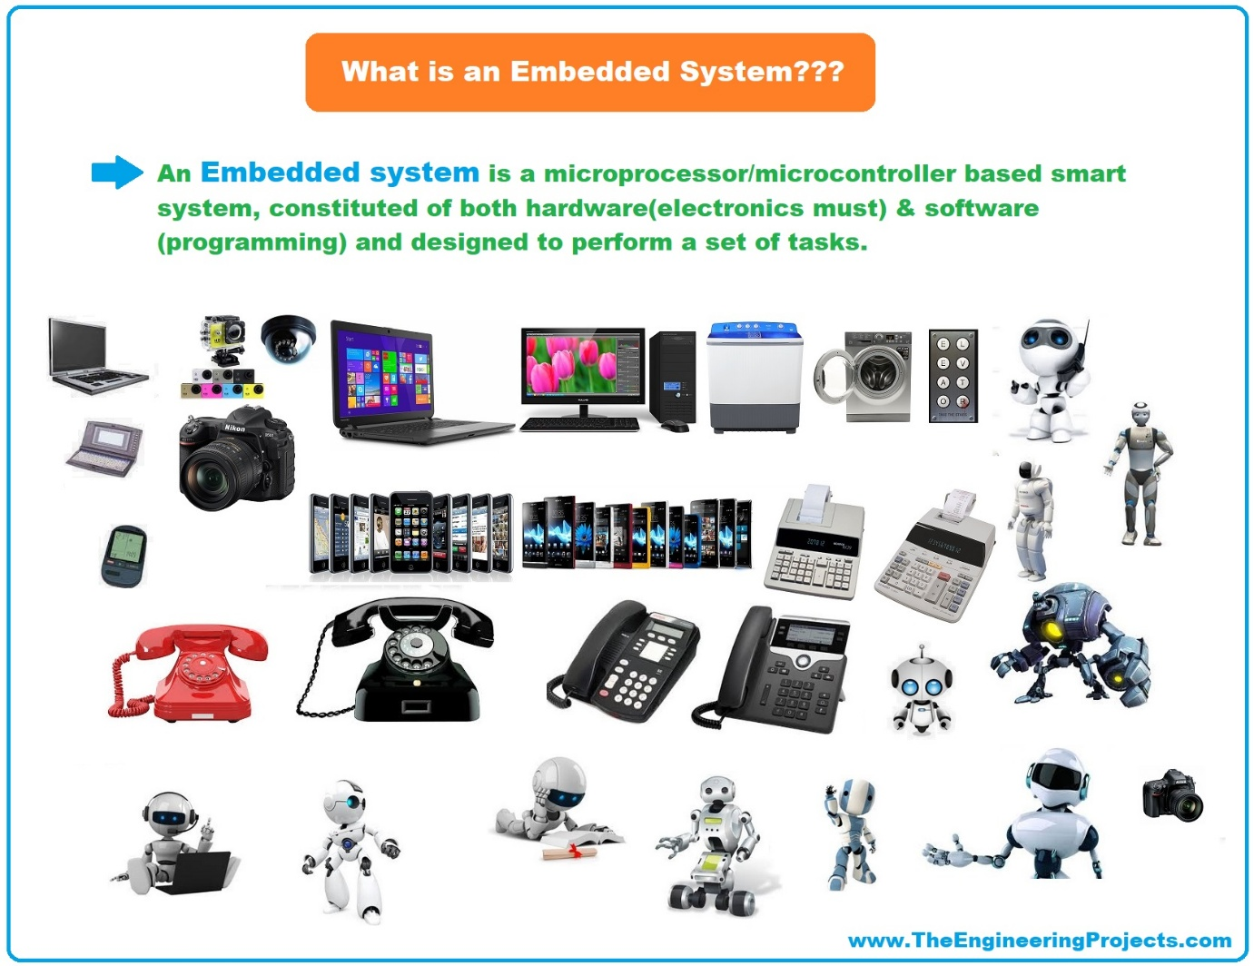

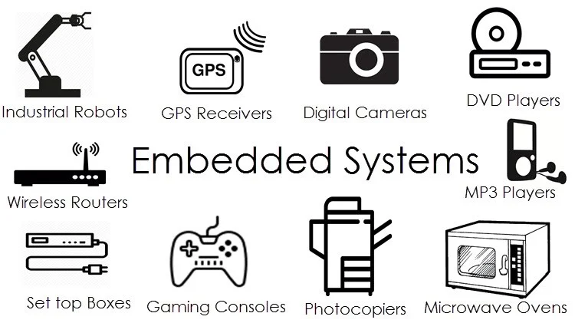
Think of it as a computer that is "embedded" inside a product that is not primarily marketed as a computer.
- A general-purpose computer (like your laptop or smartphone) is designed to run a wide variety of applications (word processors, games, browsers). You, the user, decide what software to run.
- An embedded system is designed to run one specific application, or a very limited set, over and over again. The software is usually burned into the hardware and is not meant to be changed by the end-user.
A Simple Analogy:
- Your Desktop PC is like a master chef in a large kitchen. They can prepare any dish you request (run any program).
- An Embedded System is like a toaster. It is designed to do one thing: toast bread. It does it well, it's cheap, and you don't need to install new software on it to make it toast bagels.
Everyday Examples of Embedded Systems
You interact with dozens of embedded systems every single day without even realizing it:
- Home Appliances: Microwave ovens, washing machines, refrigerators, smart thermostats, digital watches.
- Consumer Electronics: Digital TVs, cameras, gaming consoles, routers, MP3 players.
- Automotive: Modern cars contain dozens of them for engine control (ECU), anti-lock braking systems (ABS), airbag deployment, infotainment, and cruise control.
- Medical Devices: Pacemakers, insulin pumps, MRI machines, patient monitoring systems.
- Industrial Control: Factory robots, assembly line controllers, temperature controllers.
- Office Equipment: Printers, scanners, fax machines.
- Aerospace and Defense: Avionics in aircraft, guidance systems in missiles, communication systems.
Core Components of an Embedded System
Most embedded systems are built using a combination of hardware and software components:

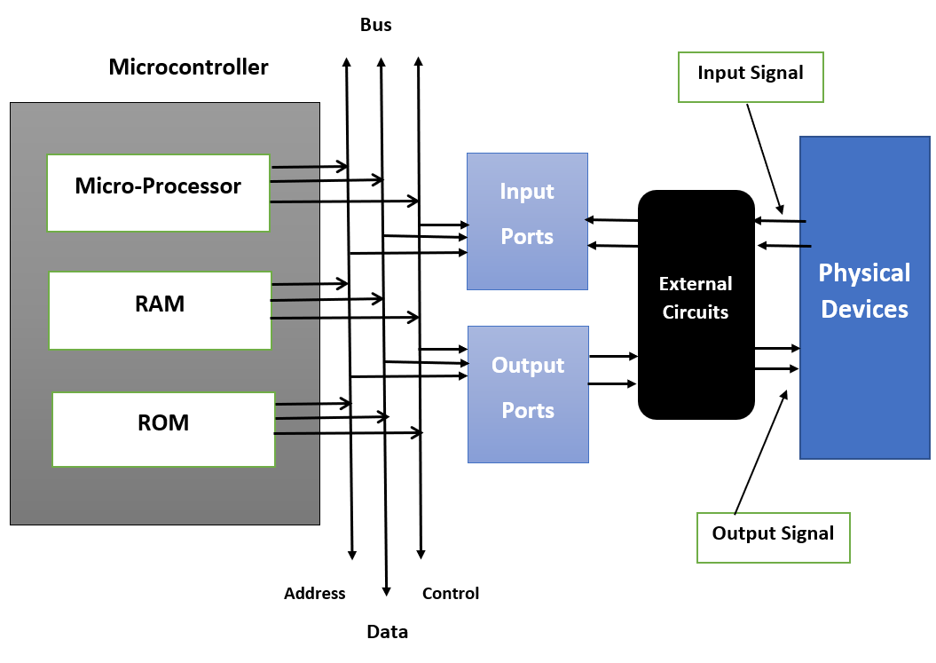
1. Hardware
- Processor (The Brain): This is the central unit that processes instructions. It can be a:
  - Microcontroller: The most common choice. It's a "computer on a chip" that includes the processor, memory (RAM and ROM), and input/output (I/O) peripherals all integrated onto a single chip. This makes it compact, cheap, and power-efficient. Examples: Arduino, PIC, ARM Cortex-M.
  - Microprocessor: A more powerful processor that requires external chips for memory and I/O. Used in more complex systems. Example: Intel x86, ARM Cortex-A (used in smartphones).
- Memory (The Storage):
  - RAM (Random Access Memory): For temporary data storage while the program is running. (Volatile: data is lost when power is off).
  - ROM/Flash Memory (Read-Only Memory): For storing the permanent program code and fixed data. (Non-volatile: data is retained when power is off).
- Input/Output (I/O) Ports (The Communication): These allow the processor to interact with the outside world.
  - Input: Sensors (temperature, light, motion), buttons, switches.
  - Output: LEDs, LCD screens, motors, actuators.
  - Communication Interfaces: USB, Ethernet, Wi-Fi, Bluetooth, I2C, SPI, CAN bus (for cars).
2. Software
- Firmware: This is the software that is stored in the non-volatile memory (like Flash). It is the low-level software that directly controls the hardware. It's what makes the hardware "go."
- Operating System (Optional): Simple embedded systems run a "bare-metal" program (a single infinite loop). More complex systems may use a Real-Time Operating System (RTOS) like FreeRTOS or a stripped-down version of Linux to manage multiple tasks efficiently and meet timing deadlines.
Key Characteristics of Embedded Systems
What sets them apart from general-purpose computers?
- Task-Specific: They are designed to do a single task, reliably and efficiently.
- Tightly Constrained: They are built with strict limitations on:
  - Cost: Since they are often mass-produced, even saving a few cents per unit is a huge deal.
  - Power Consumption: Many run on batteries for long periods (e.g., a smartwatch that lasts all day).
  - Size and Weight: They need to fit into the product's form factor.
  - Processing Power: They often have just enough processing power to do their job, not a drop more.
- Highly Reliable and Stable: A failure in an embedded system can be catastrophic. Your car's airbag system or a medical pacemaker must work perfectly 100% of the time. They are often designed to run for years without a single reboot.
- Real-Time Operation: Many embedded systems are "real-time," meaning they must respond to events in the physical world within a strict, guaranteed timeframe. If a car's airbag detects a crash, it must deploy within milliseconds, or it's useless.
The Design Process (Simplified)
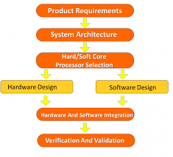
Creating an embedded system is a multidisciplinary effort that involves:
- Requirement Analysis: Understanding the problem: What exactly must the system do? What are the cost, power, and size limits?
- Hardware Design: Selecting the right processor, sensors, and other components, and designing the circuit board (PCB).
- Software/Firmware Design: Writing the code that will run on the hardware to perform the task.
- Integration and Testing: Combining the hardware and software and rigorously testing it to ensure it meets all requirements and is reliable. This often involves Hardware-in-the-Loop (HIL) testing.
- Deployment and Maintenance: Manufacturing the final product and, increasingly, providing software updates in the field.
Basics of electronics, Components

Part 1: The Core Concepts - The "Why" Behind the "How"
Before we grab a soldering iron, we need to understand what's happening inside the wires. It all boils down to three fundamental concepts, best understood with a water analogy.
Electrical Term | Unit (Symbol) | Water Analogy | Description
Voltage (V) | Volts (V) | Water Pressure | The "push" that makes electrons move. It's the potential energy difference between two points. In a robot, a battery provides voltage (pressure) to the system.
Current (I) | Amperes or Amps (A) | Flow Rate | The actual flow of electrons through a wire. It's the quantity of electricity moving. Too much current can "pop" a component, like too much water bursting a pipe.
Resistance (R) | Ohms (Ω) | Pipe Narrowing | The opposition to the flow of current. A component with high resistance lets less current through. We use resistors intentionally to control current.
The Golden Rule: Ohm's Law
This is the single most important equation in all of electronics. It defines the relationship between our three concepts.
V = I * R
- If you know two of the values, you can calculate the third. For example, to find the current in a circuit: I = V / R.
Another Key Concept: Power (P)
Power is the rate at which your robot uses energy, mostly turning it into heat, light, or motion.
P = V * I (measured in Watts)
This is critical for choosing batteries and making sure your components don't overheat and fail.

Part 2: Essential Passive Components
These components don't require an external power source to operate. They shape and control the electrical signals.
1. Resistors
- What is it? A resister is a passive two-terminal electronic component that resists the flow of electric current. It does this by converting electrical energy into heat. Why Use It? : Resistors are commonly used to limit the amount of current flowing through a particular part of a circuit. Resistors can be used to create a specific voltage output from a higher voltage source. This is crucial to prevent components such as LEDs, transistors, and integrated circuits from being damaged by excessive current
- Schematic Symbol: A zig-zag line (-www-).
- Key Specs:
  - Resistance (Ohms): How much it resists. Identified by colored bands on its body. Learn to read the resistor color code! (We'll have a separate lab on this).
  - Power Rating (Watts): How much heat it can safely dissipate. Common ones are 1/4W and 1/2W.
- Robotics Application: Putting a resistor in series with an LED is the classic example. An LED without a current-limiting resistor is a dead LED.
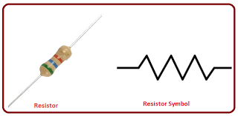
2. Capacitors
- Function: A capacitor is a passive electronic component that stores electrical energy in an electric field. It consists of two conductors separated by an insulator, allowing it to store and release charge.
- Schematic Symbol: Two parallel lines (-||-). One is often curved to indicate polarity (for electrolytic capacitors).
- Key Specs:
  - Capacitance (Farads, F): How much charge it can store. Usually in microfarads (µF) or picofarads (pF).
  - Voltage Rating: The maximum voltage it can handle before failing.
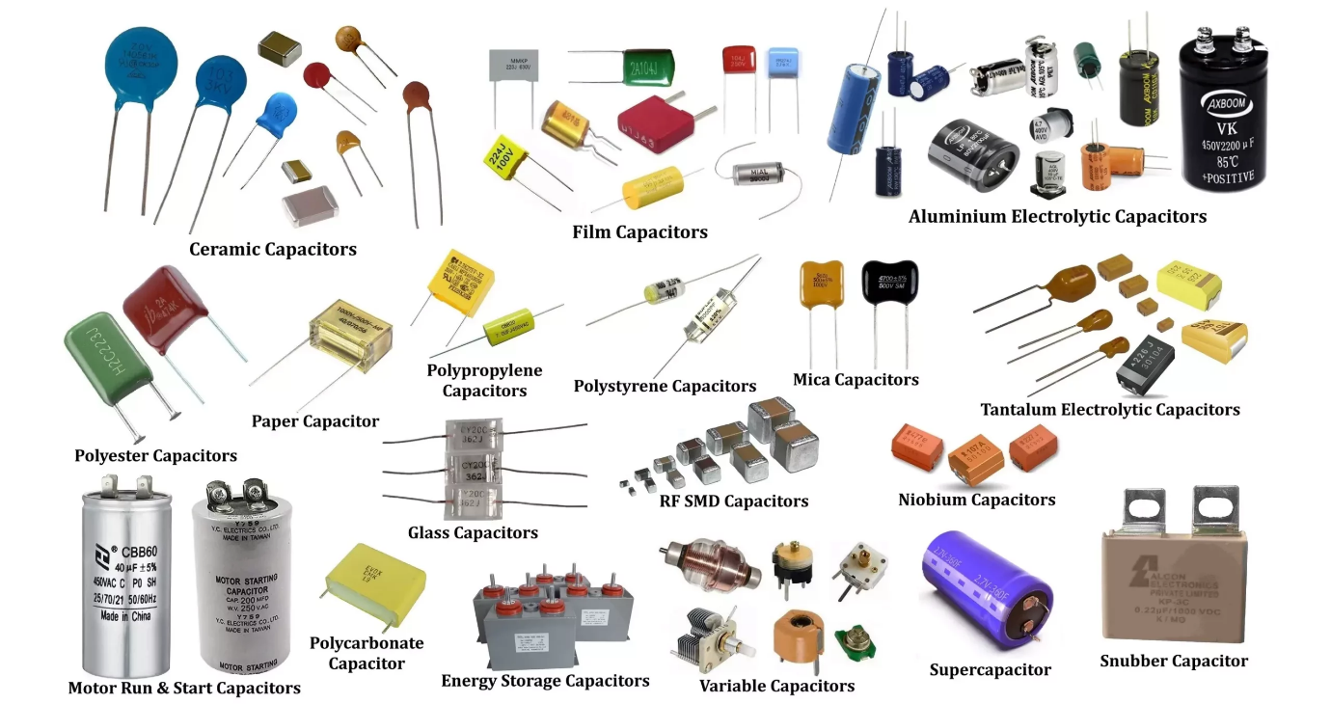
Why Use a Capacitor?
  - Filtering Noise: When a motor starts, it can cause a voltage drop in the rest of the circuit. A large capacitor placed near the motor acts like a reservoir, smoothing out these power fluctuations.
  - Decoupling: Placing a small capacitor right next to a microcontroller's power pin to filter out high-frequency noise.
  - Energy Storage : Capacitors can store energy and release it when needed, making them useful in power supplies and timing circuits.
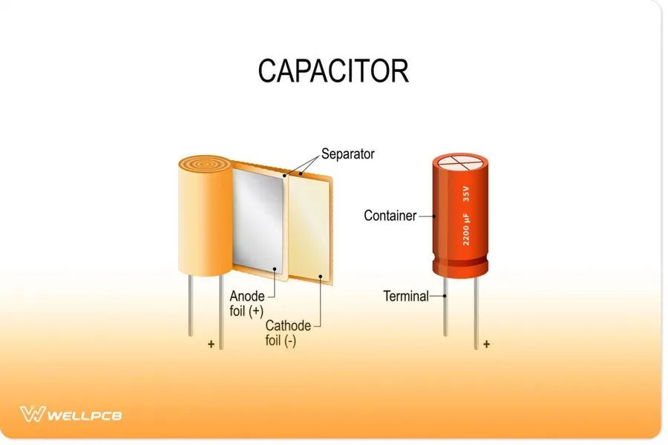

Applications of Capacitors:
Power Supplies: Capacitors are used in power supplies to smooth out ripple and provide a stable voltage.
Timing Circuits: Capacitors are used in timing circuits, such as in oscillators and clocks, to control the timing of signals.
Coupling and Filtering: Capacitors are used to couple signals between stages of a circuit and to filter out unwanted frequencies.
Part 3: Essential Semiconductor Components
These components are the "brains" of the operation. Their conductivity can be controlled and changed.
Diode :
What is a Diode?
A diode is a two-terminal electronic component that allows the flow of electric current in only one direction. It is a fundamental building block of many electronic devices and circuits.
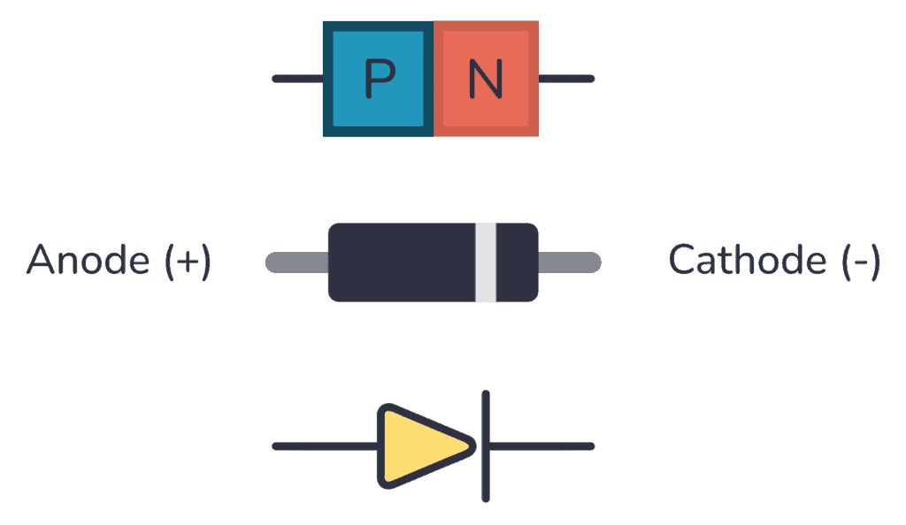
Why Use a Diode?
Rectification :
Diodes are used to convert alternating current (AC) into direct current (DC)
Voltage Regulation :
Diodes can be used in voltage regulator circuits to maintain a stable output voltage.
Signal Conditioning :
Diodes can be used to shape and condition electronic signals, such as in clipping and clamping circuits.
Applications of Diodes :
Power Supplies :
Diodes are used in power supplies to convert AC to DC.
One-Way Valve :
Diodes act as one-way valves, allowing the flow of electric current in only one direction. This property makes them essential for rectification, signal conditioning, and protection circuits.
LED Circuits :
Light-emitting diodes (LEDs) are a specialized type of diode that emit light when current flows through them.

Part 3: Essential Component :
Transistors : A transistor is a semiconductor device used to amplify or switch electrical signals and power. It is one of the basic building blocks of modern electronics. It is composed of semiconductor material, usually with at least three terminals for connection to an electronic circuit.

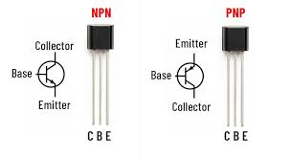
Transistor ● 1 Emitter: Emits majority charge carriers into the base.
2 Base: Controls the flow of current carriers from the emitter to the collector.
3 Collector: Collects the majority charge carriers that pass through the base region

2. Semiconductor Basics (Foundation of Transistor)
To understand transistor structure properly, you must understand semiconductor types.
2.1 Intrinsic Semiconductor
Pure silicon without impurities. It has equal number of electrons and holes.
2.2 Extrinsic Semiconductor
When impurities are added, it becomes:
N-type:
- Majority carriers: Electrons
- Minority carriers: Holes
P-type:
- Majority carriers: Holes
- Minority carriers: Electrons
A transistor is made by combining N-type and P-type materials.

3. Bipolar Junction Transistor (BJT)
3.1 Definition
A Bipolar Junction Transistor is a current-controlled device that uses both electrons and holes for conduction.
It contains:
- Two PN junctions
- Three semiconductor layers
- Three terminals
4. Structure of BJT
4.1 NPN Structure
Layer arrangement:
N – P – N
Terminals:
Emitter (E)
Base (B)
Collector (C)
Structural Design Explanation
Emitter:
- Heavily doped
- Injects large number of electrons
- Small in size
Base:
- Extremely thin (few micrometers)
- Very lightly doped
- Controls current flow
- Only small recombination occurs here
Collector:
- Moderately doped
- Larger in size
- Designed to handle more heat
- Collects electrons
The thin base is the most important structural feature because it allows most electrons to pass to collector instead of recombining.
4.2 PNP Structure
Layer arrangement:
P – N – P
Same terminals but current direction is reversed.
Majority carriers are holes.
5. Working of BJT in Detail (NPN Example)
When:
Emitter-Base junction → Forward biased
Collector-Base junction → Reverse biased
Process:
- Electrons move from emitter to base.
- Since base is thin, most electrons pass through.
- Reverse-biased collector attracts electrons.
- Large collector current flows.
Small base current controls large collector current.
Current relation:
IE = IC + IB
Collector current:
IC ≈ β × IB
Where β is current gain.
6. Biasing of Transistor
Biasing means applying proper DC voltages to operate transistor correctly.
Types of Biasing
- Fixed Bias
- Collector-to-Base Bias
- Voltage Divider Bias (most stable)
Voltage divider bias is widely used because it provides stable operation.

7. Regions of Operation (Very Important)
7.1 Cutoff Region
- Both junctions reverse biased
- IC ≈ 0
- Transistor OFF
Used in switching circuits.
7.2 Active Region
- Emitter-Base forward biased
- Collector-Base reverse biased
- Used for amplification
7.3 Saturation Region
- Both junctions forward biased
- Maximum current flows
- Transistor fully ON
8. Transistor as a Switch (Detailed)
OFF Condition:
IB = 0
IC = 0
ON Condition:
Sufficient base current applied
IC maximum
Used in:
- LED control
- Relay driver
- Motor control
- Microcontroller output interface
9. Transistor as Amplifier (Detailed)
In active region:
Small AC signal at base → Larger signal at collector
Voltage gain depends on:
- Load resistance
- Current gain (β)
- Biasing
Applications:
- Audio amplifier
- RF circuits
- Signal conditioning
10. BJT Configurations
10.1 Common Emitter (CE)
- High voltage gain
- High current gain
- Most commonly used
10.2 Common Base (CB)
- Low input impedance
- Used in high-frequency circuits
10.3 Common Collector (CC)
- Voltage gain ≈ 1
- Used as buffer
- High input impedance
11. Market-Available BJT Transistors (Detailed)
Small Signal Transistors
BC547
- IC max: 100mA
- VCE max: 45V
- Package: TO-92
- Used in small amplifier and switching circuits
BC557
- Complementary to BC547
- Used in push-pull amplifier
2N2222
- IC max: 800mA
- Stronger than BC547
- Used in relay and motor switching
2N3904
- General purpose
- Used in low-power circuits
2N3906
- PNP version of 2N3904
Power Transistors
TIP122
- Very high gain
- Used for high current loads
- Package: TO-220
2N3055
- Used in power amplifiers
- Metal body (TO-3 package)

12. MOSFET (Field Effect Transistor)
Unlike BJT, MOSFET is voltage controlled.
Terminals:
Gate
Drain
Source
Common market MOSFETs:
IRFZ44N
- High current motor control
IRF540
- Power supply circuits
BS170
- Low power switching
13. Transistor Packages
TO-92
- Small plastic package
- Used in BC547, 2N2222
TO-220
- Medium power
- Used in TIP122, MOSFET
TO-3
- Metal case
- Used in 2N3055

14. Important Electrical Parameters
- VCE max – Maximum voltage
- IC max – Maximum collector current
- Power dissipation
- β (gain)
- Switching speed
- Junction temperature
15. Practical Selection Guide
For LED:
BC547
For Relay (5V or 12V):
2N2222 or TIP122
For DC Motor:
TIP122 or IRFZ44N
For Audio Amplifier:
BC547, 2N3055
For Arduino switching:
2N2222 or MOSFET
16. Advantages of Transistor
- Small size
- Low cost
- High efficiency
- Fast switching
- Long life
17. Disadvantages
- Sensitive to heat
- Limited power handling (small signal types)
- Requires proper biasing

